Effective November 1, 2014, three important changes will affect Bryn Mawr College medical plan enrollees

- Regardless of any Open Enrollment plan change, every enrollee is to receive a new ID card with a new ID number.

- Temporary ID cards can only be printed by the enrollee. Previously Human Resources could print temporary cards but will no longer be able to do so. The temporary ID can be accessed via ibxpress.com or the IBX app on iphone or Android platforms, as outlined below.

- Keystone HMO and POS enrollees can no longer contact Independence Blue Cross to change a Primary Care Physician (PCP). For the time being, a PCP change has to go through Human Resources.

Please start using the new ID on November 1st. Using the old ID card could result in access to care issues, as providers/pharmacists may be unable to verify coverage based on an old ID number. Also please verify that the medical plan indicated on the ID card is the correct plan for you. If you find any information is not as expected, please contact Tina Bockius in Human Resources at 610-526-5263.

Effective November 1, 2014 every medical plan enrollee can access the new ID card and number through ibxpress.com. Ibxpress is the secure Independence Blue Cross Member portal which contains plan information, claims data, open referrals (for Keystone enrollees) and the ability to print a temporary ID card. Members can go to www.ibx.com and either register for their ibxpress account or, if they are an existing member, go to www.ibxpress.com and log in.
On the ibxpress page, members can print out their ID card.
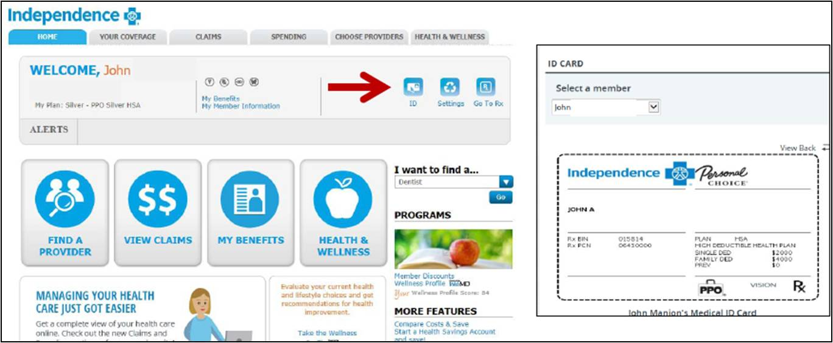
Members can also use the smartphone app by searching "ibx" on the app store, and can then access their new ID number on their smartphone. The app is available for both iphone and Android users. We have made our very best efforts to ensure members receive their new ID cards before November 1, but please print a temporary ID card if you do not receive it by November 1.

Lastly – as a reminder – it is very critical that Keystone HMO and POS enrollees communicate any PCP change through Human Resources. The PAISIG consortium through which the College purchases benefits started using a third party administrator called Businessolver and all PCP changes need to first be communicated to Businessolver (through Human Resources) and are then communicated by Businessolver to Independence Blue Cross. If an enrollee contacts Independence Blue Cross directly to change a PCP, this change will not be updated – even if the Independence Blue Cross representative indicates otherwise – and will create problems when using the newly intended PCP.

Please contact Human Resources if you have any questions or concerns.

